Week 6 | Active transport
  - Weekly teaching plan | LAUNCH Science | Autumn 1
Timetable: Monday, Wednesday and Friday | Period 1 | 09:30–10:10
Week commencing: __________________
Day | Lesson | Learning focus
Monday | W6L1 · Introduce | I can explain how active transport moves substances against a concentration gradient and needs energy from respiration.
Wednesday | W6L2 · Explore | I can use concentration and respiration evidence to decide when diffusion alone cannot explain uptake.
Friday | W6L3 · Do | I can select and justify the correct transport process in unfamiliar biological scenarios.

Prepare once for the week
Open this week’s folder. Download or sync the complete folder to the classroom PC. Start the named PowerPoint in Slide Show mode. Print the selected PDF route; the Word sheet is an editable master. Keep teaching plans and mark schemes in staff storage.
Use counters or the projected model. Friday includes printable scenario cards. Pupils can place, number or point to cards; cutting and dragging are optional. Ask for concentration and energy evidence before naming the process.

Teaching decisions
Use one shared route: PowerPoint activity, paper or the linked online model. A video replaces up to 90 seconds of the relevant model, rather than adding time. Use the prompt and still diagram if playback is unavailable. Linked videos are freesciencelessons GCSE concept explanations; their AQA practical numbering is not this centre’s assessment record.
If more time is needed, drop optional continuation. Keep one model, one supported attempt and independent evidence, then the Exit. Offer the least help first and leave the pupil’s choice and explanation theirs.
Timetable source: Timetables 2026_2027 (2).xlsx, Launch B5/D5/F5; Matt D3/D9/D15.

W6L1 | Active Transport
  - Monday | 09:30–10:10 | Introduce
Say: Active transport uses energy released by respiration to move a substance against its concentration gradient through membrane transport proteins.

09:30–09:33 | Arrival
What does ‘down a concentration gradient’ mean? Receive a short answer or a point to the image.

09:33–09:37 | Starter
Mineral ions enter a root hair cell even when their concentration is already higher inside. Can diffusion alone explain this? Take a reason before revealing the answer.

09:37–09:42 | I Do
The observed movement is from lower concentration outside to higher concentration inside. That direction is against the concentration gradient, so diffusion cannot be the full explanation. Membrane proteins use energy from respiration to move the substance.

09:42–09:47 | We Do
Which combination identifies active transport? Answer: A substance moved against its concentration gradient and needed energy. Ask for the deciding step.
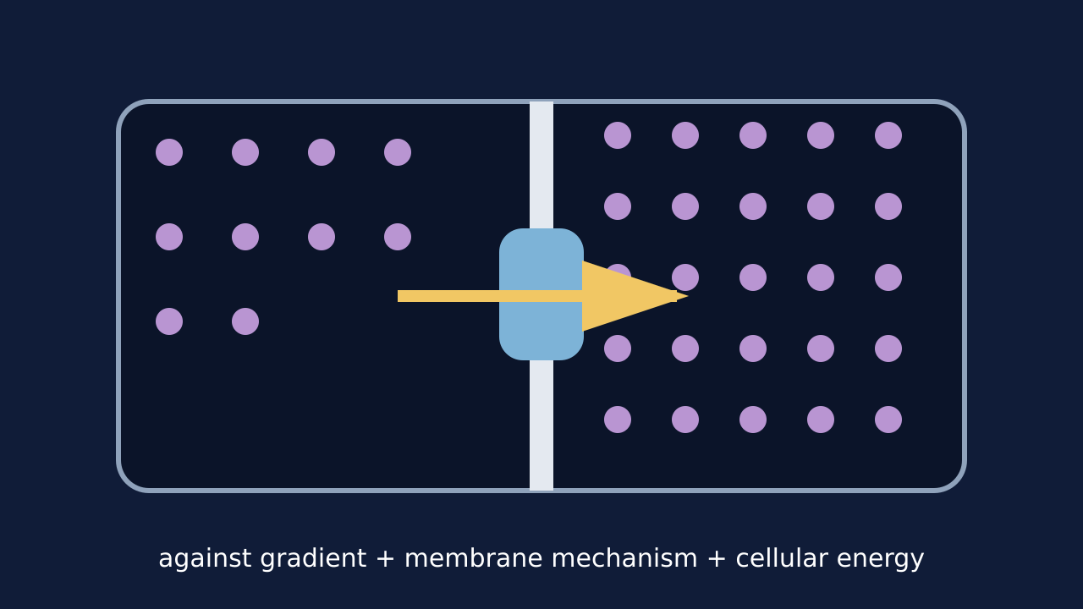
Teaching visual from the matching online lesson. A model, not evidence of practical completion. Use within the modelling time.

W6L1 | Continue the lesson
  - Second half | Keep the same 40-minute sequence

09:47–09:51 | I Do 2
Diffusion: net particle movement is down a concentration gradient. It does not need energy from respiration. Osmosis: water moves through a partially permeable membrane. It does not need energy from respiration. Active transport: a substance moves against its concentration gradient using energy from respiration.

09:51–09:57 | We Do 2 · Task
Draw two equal-volume regions: 2 nitrate-ion counters outside and 8 inside, separated by a membrane. Use the shared-task board; reveal only after a pupil decision.

09:57–10:07 | Independent Task
A cell keeps taking in nitrate ions when their concentration is lower outside than inside. Explain why active transport is needed. Predict what happens if respiration falls. Select one correction on the same work.

10:07–10:10 | Exit
Why is ‘active transport is fast diffusion’ scientifically wrong? Receive a specific learning request and agree the next action.
Watch for: Diffusion is random at particle level. The contrast is net movement down a gradient versus energy-dependent movement against it, not “diffusion never moves backwards”.
Least help first: Ask the pupil to compare concentrations and trace the movement arrow before naming the process.

W6L2 | Root Hairs And Gut
  - Wednesday | 09:30–10:10 | Explore
Say: Use two clues: direction relative to the gradient and dependence on respiration. “Root hair” or “gut” alone does not determine every transport mechanism.

09:30–09:33 | Arrival
Why can root hairs need active transport? Receive a short answer or a point to the image.

09:33–09:37 | Starter
Mineral uptake falls when root cells receive less oxygen. Which explanation should be investigated first? Take a reason before revealing the answer.

09:37–09:42 | I Do
Root hair cells contact soil water across a large surface area and may take up mineral ions against a gradient. Small-intestine cells absorb digested food. Diffusion can help, but active transport can keep uptake going against the gradient. Evidence that uptake falls when respiration is inhibited supports an energy-dependent mechanism.

09:42–09:47 | We Do
Which evidence most strongly supports active transport rather than diffusion alone? Answer: Uptake continues against the gradient and falls when respiration is inhibited. Ask for the deciding step.
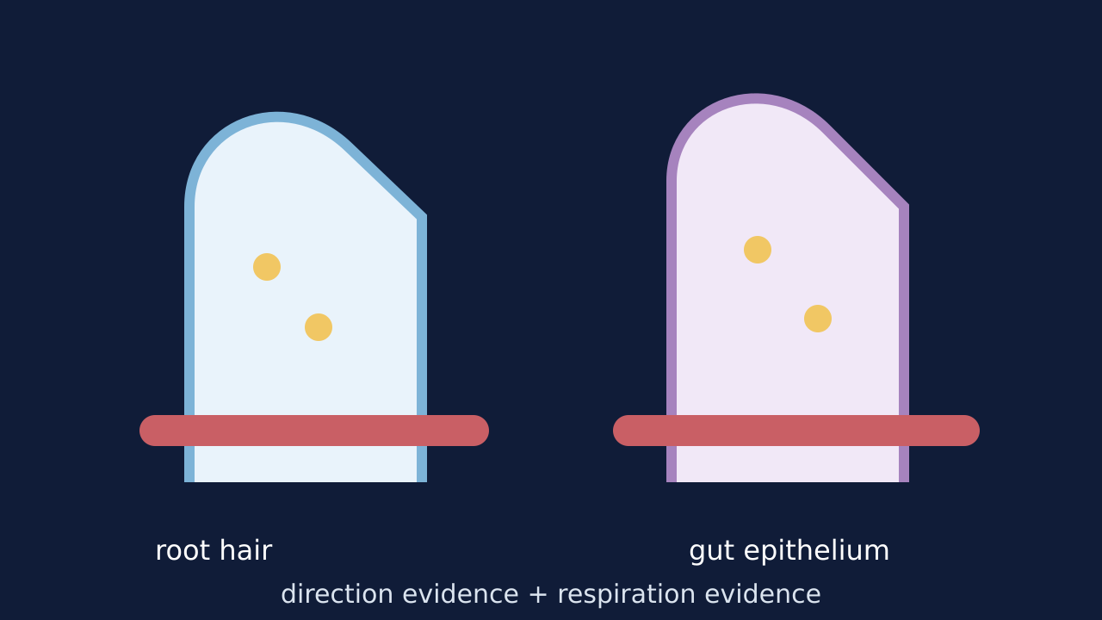
Teaching visual from the matching online lesson. A model, not evidence of practical completion. Use within the modelling time.

W6L2 | Continue the lesson
  - Second half | Keep the same 40-minute sequence

09:47–09:51 | I Do 2
Evidence 1: direction against the concentration gradient. Evidence 2: uptake changes when respiration or energy supply changes. Large surface area and many transport proteins allow more uptake. Energy released by respiration supports active uptake.

09:51–09:57 | We Do 2 · Task
Read the concentration evidence. The numbers are model values in the same units. Use the shared-task board; reveal only after a pupil decision.

09:57–10:07 | Independent Task
Glucose concentration in the small intestine becomes lower than in an epithelial cell, but glucose uptake continues. Uptake falls when respiration is inhibited. Explain the mechanism and link one cell adaptation to its function. Select one correction on the same work.

10:07–10:10 | Exit
Why is ‘root hair cells have a large surface area’ incomplete without a function link? Receive a specific learning request and agree the next action.
Watch for: The gut can use more than one transport mechanism. Here the stated against-gradient uptake and energy evidence support active transport.
Least help first: Ask whether concentration evidence alone is enough, then prompt for a second clue about energy or respiration.

W6L3 | Compare Transport
  - Friday | 09:30–10:10 | Do
Say: Read the evidence before naming the process. Some statements belong to more than one process; some scenarios do not contain enough information.

09:30–09:33 | Arrival
Which process moves water only? Receive a short answer or a point to the image.

09:33–09:37 | Starter
Water enters a plant cell through a partially permeable membrane. Which single clue should decide the process first? Take a reason before revealing the answer.

09:37–09:42 | I Do
Ask what substance moves: water only or another substance. Ask whether movement is down or against the relevant concentration gradient. Ask whether a partially permeable membrane and cellular energy are part of the evidence.

09:42–09:47 | We Do
Which sentence compares rather than lists? Answer: Both can move substances across membranes, whereas only active transport can move against a concentration gradient using cellular energy. Ask for the deciding step.
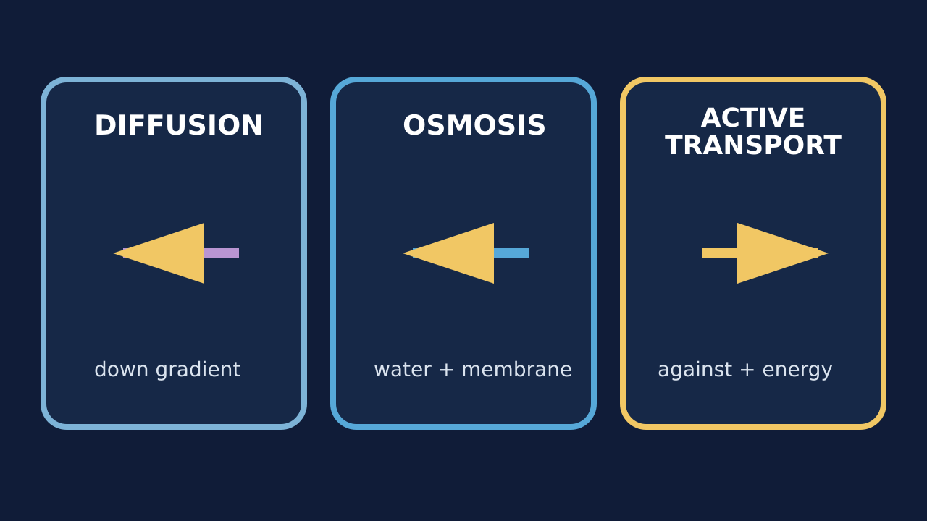
Teaching visual from the matching online lesson. A model, not evidence of practical completion. Use within the modelling time.

W6L3 | Continue the lesson
  - Second half | Keep the same 40-minute sequence

09:47–09:51 | I Do 2
Both diffusion and active transport can move solutes across cell membranes. Whereas diffusion is net movement down a concentration gradient, active transport can move against it. Only active transport requires cellular energy; osmosis specifically concerns water through a partially permeable membrane.

09:51–09:57 | We Do 2 · Task
Cut the four scenario cards or number them on paper; a seated route works equally well. Use the shared-task board; reveal only after a pupil decision.

09:57–10:07 | Independent Task
Compare diffusion and active transport. Then decide which process best explains each case: (1) oxygen entering blood from alveoli; (2) water entering a root hair cell through its partially permeable membrane; (3) mineral ions entering a root hair cell against their concentration gradient. Justify each decision. Select one correction on the same work.

10:07–10:10 | Exit
Complete with precision: only active transport… Receive a specific learning request and agree the next action.
Watch for: “Water only” points to osmosis, but the membrane and relative solutions still matter. Movement through a membrane alone does not prove active transport.
Least help first: Ask for the deciding clue before accepting a process label; then ask for one linked comparison.

