PUPIL WORKSHEET

Backbones and no backbones
  - Autumn 1 · Week 3 · Lesson A
Name: ____________________________ Date: __________________
Classify animals using evidence of an internal backbone, and explain why size, fur or legs are not reliable tests.
Use this sheet with the lesson. You may point, sign, speak, draw, write, dictate or direct an adult. Keep your first idea so you can show what changed.

1. My first idea
Choose an animal. Predict first; keep the idea so you can compare it with evidence.
- Animal: ___.
- I think it has / does not have a backbone / I am unsure.
- My first reason: ___.

PUPIL TASK / Autumn 1 · Week 3 · Lesson A

2. Use the body evidence
  - Write, draw, point or dictate as agreed with your teacher.
Read or listen to each clue. Mark vertebrate (V), invertebrate (I), or ask for help.
Animal | Body evidence | My group
Fish | Internal bones include a backbone.
Frog | Internal bones include a backbone.
Mouse | Internal bones include a backbone.
Snail | A shell; no backbone.
Crab | Hard outer case; no backbone.
Earthworm | Muscles and fluid support; no backbone.

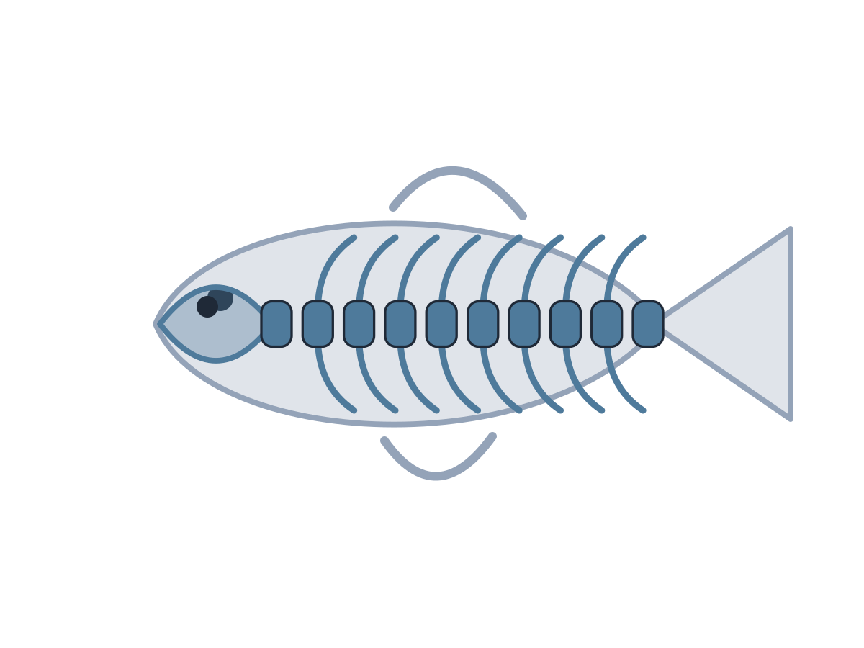
PUPIL TASK / Autumn 1 · Week 3 · Lesson A

3. Which clues count?
  - Write, draw, point or dictate as agreed with your teacher.
Use the new clues, not size or the number of legs.
Animal | Evidence | My group
Bat | Wings and an internal backbone.
Snake | An internal backbone; no legs.
Crab | An outer case, but no backbone.
Jellyfish | No internal backbone.

PUPIL TASK / Autumn 1 · Week 3 · Lesson A

4. My evidence explanation
  - Write, draw, point or dictate as agreed with your teacher.
Choose one animal. You can point to a label or ask an adult to write your words.
- The ___ is a ___ because ___.
- The clue that matters is ___.
- I kept / changed my idea because ___.

Choose a response route
Agree one route with your teacher; you do not need every route.

Supported
Use a choice of two labelled groups with an adult reader; point to the body clue.

Standard
Classify the supplied animals and explain one choice using because.

Stretch
Use the rule on a bat/snake case and explain why size, fur or legs are unreliable.
Keep this record for Wednesday Week 3.

