PUPIL WORKSHEET

Build and test a muscle model
  - Autumn 1 · Week 4 · Lesson B
Name: ____________________________ Date: __________________
Construct or direct a safe card-arm model, demonstrate both muscle roles and evaluate a model limitation.
Use this sheet with the lesson. You may point, sign, speak, draw, write, dictate or direct an adult. Keep your first idea so you can show what changed.

1. Build or direct the safe model
Adult prepares card, holes, fixed split pin and opposite-side pull tabs. Keep model on table. Never use stretched elastic.
- My role: build / direct / label / explain.
- The adult checked ___.
- The join can turn: yes / adult adjustment needed.

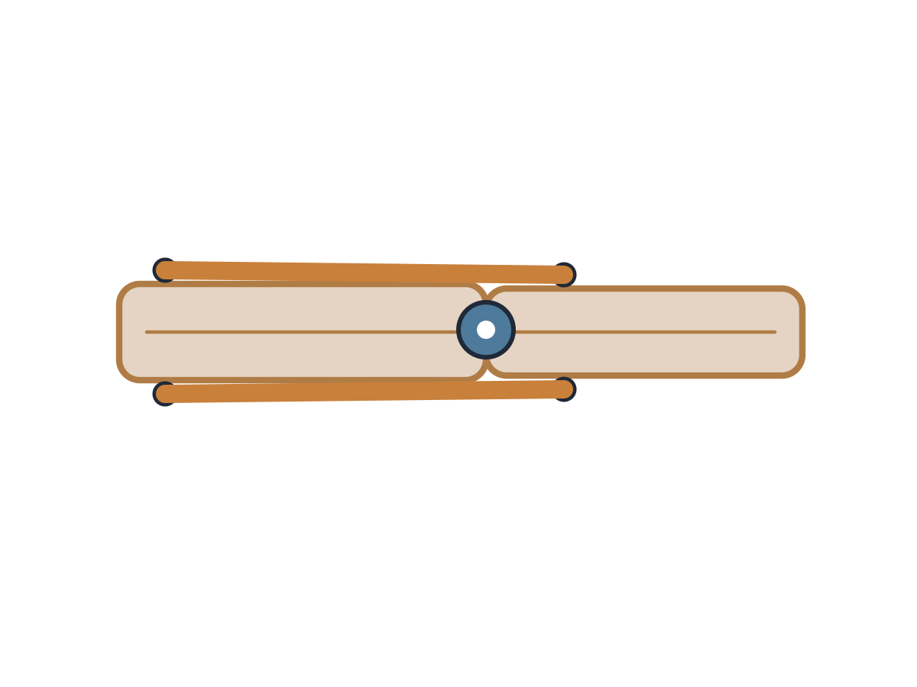
PUPIL TASK / Autumn 1 · Week 4 · Lesson B

2. Record the two actions
  - Write, draw, point or dictate as agreed with your teacher.
Use each gentle pull and place the muscle labels.
Action | Biceps label | Triceps label | What I observed
Bend at elbow
Actively straighten

PUPIL TASK / Autumn 1 · Week 4 · Lesson B

3. Check, improve and explain
  - Write, draw, point or dictate as agreed with your teacher.
Check a label or model join. Ask an adult to adjust the join if needed.
- What I checked: ___.
- My change: ___.
- My science reason: ___.
- This model differs from a real arm because ___.

PUPIL TASK / Autumn 1 · Week 4 · Lesson B

4. Feedback and exit
  - Write, draw, point or dictate as agreed with your teacher.
Tell the adult an access need or pass. Choose one question and explain or point.
- Supported: which muscle contracts for a bend?
- Standard: explain both roles for active straighten.
- Stretch: why do we need pulls on opposite sides?

Choose a response route
Agree one route with your teacher; you do not need every route.

Supported
Use adult-prepared model and point to or direct labels for each action.

Standard
Build or direct both moves and explain the two muscle roles.

Stretch
Compare model with living muscle and justify a precise improvement.
Next: the current Week 5 lesson.

