PUPIL WORKSHEET

Muscles work in pairs
  - Autumn 1 · Week 4 · Lesson A
Name: ____________________________ Date: __________________
Explain how biceps and triceps take turns contracting to bend and actively straighten the elbow, using a safe model.
Use this sheet with the lesson. You may point, sign, speak, draw, write, dictate or direct an adult. Keep your first idea so you can show what changed.

1. The model and the body
Watch the adult model. Match a part to what it represents.
- Card strip represents ___.
- Turning join represents ___.
- Loose string represents ___.
- One way the model differs from a body: ___.

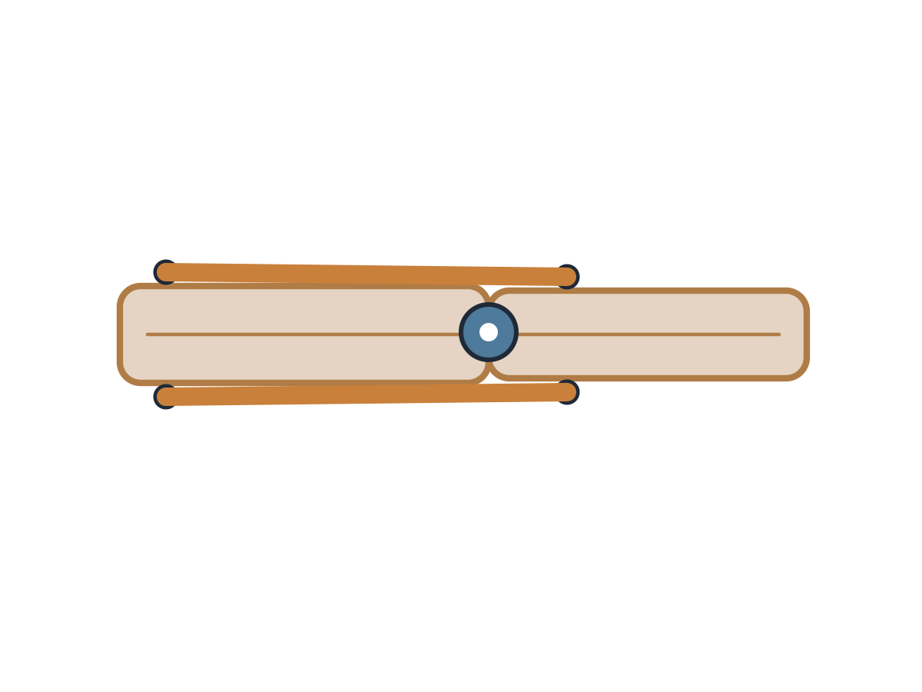
PUPIL TASK / Autumn 1 · Week 4 · Lesson A

2. Complete the muscle-pair table
  - Write, draw, point or dictate as agreed with your teacher.
Place, point to or write CONTRACTS and RELAXES.
Action | Biceps | Triceps
Bend at elbow
Actively straighten at elbow

PUPIL TASK / Autumn 1 · Week 4 · Lesson A

3. Keep or correct the statement
  - Write, draw, point or dictate as agreed with your teacher.
Explain the science using a movement in the model.
Statement | True / correct it
Muscles can pull.
Muscles push bones away.
Biceps and triceps work as a pair.
Bones move on their own.

PUPIL TASK / Autumn 1 · Week 4 · Lesson A

4. Explain one movement
  - Write, draw, point or dictate as agreed with your teacher.
Choose a bend or active straighten. You can direct the adult and place labels.
- My chosen action: ___.
- The ___ contracts while the ___ relaxes.
- I checked / changed ___ because ___.

Choose a response route
Agree one route with your teacher; you do not need every route.

Supported
Point to the named muscle and CONTRACTS/RELAXES label while adult operates.

Standard
Explain both roles during bend and active straighten.

Stretch
Explain one limitation of the model and distinguish active straighten from gravity lowering.
Keep this record for Wednesday Week 4.

